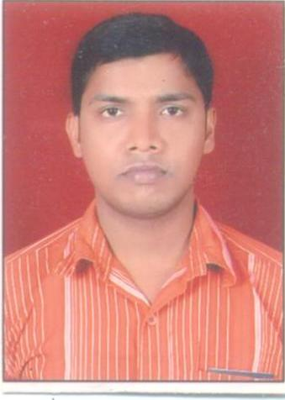
Samiranjan Biswal

H. No.136/22,Gali No-10,
Gandhi nagar, (Haryana)
M ob: 9990602699
Email ID: samiranjan_biswal@yahoo.co.in

“To be a member of Professionally managed organization that provides challenging Opportunities and give me a challenging position, which could fully develop my inherent strength of knowledge and give me consequent career growth prospects.”

WORK EXPERIENCE:

- Presently working with M/S Brij Designs. Sectir-37, Gurgaon as a HR Executive from 02-01-2013 to tilldate.
- 1 Year Experience with M/S Knit Craft Apparels intl.ltd.Udyog Vihar, Gurgaon as a HR Executive from 10-03-2012 to 30-12-2013.
- 3 Years Experience in M/s Lilliput Kidswear Ltd. Manesar Gurgaon as HR Executive from 08.02.2009 to 10-01-2012.

JOB RESPONSIBILITY: -
- Recruitment of all categories employees.
- New Joining formalities & induction and verification check of employees.
- Maintaining Attendance register, Leave register & Wages register.
- Maintaining record for Compliance.
- Making Salary and wages through Inquisitor & Mega Soft.
- Online ESIC and EPF Challan.
- Maintaining of Personal File of all employees.
- Grievance handling & Related to P&A activities etc.
- Co-ordinate with all HR activities.

EDUCATIONAL QUALIFICATION:

- M.B.A from Tilak Maharashtra University, Pune.
- Bachelor of Science (Physics) from Utkal University, Bhubaneswar Odisha.
- Intermediate from CBSE, Bhubaneswar (Odisha).
- High School from BSE, Cuttack (Odisha).

OTHER ACHIEVEMENT & TECHNICAL QUALIFICATION:
- Computer: Payroll (Inquisitor,NNOA, Mega Soft & Visual Gems), Time Office (Star link) M.S. Office & Internet etc.
- Career EDGE from NIIT.
REFERENCE

Mr.Rajesh Poswal
HR & Compliance Manager
Knit Craft Apparels Intl. (p) Ltd.

PERSONAL PROFILE:
Father’s Name: Sh. Prafulla ch Biswal
Date of Birth: 15th may’1986
Languages: Hindi, English & Odia
Area of Interest: Socializing, Listening music.
Correspondence Address: VI-Uchharapara,PO-Barua
DI-Kendrapara ,Odisha.
EXPECTED SALARY: Negotiable

Declaration: - I hereby affirm that the information in this documents is accurate and true to the best of my knowledge.

Date:
Place: Samiranjan Biswal

